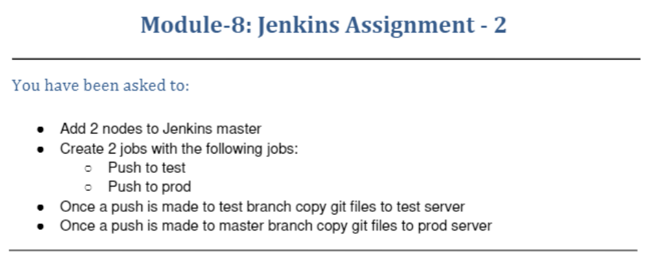
ubuntu@ip-172-31-25-211:~$ sudo service jenkins status
● jenkins.service - LSB: Start Jenkins at boot time
Loaded: loaded (/etc/init.d/jenkins; generated)
Active: active (exited) since Thu 2021-12-09 18:36:10 UTC; 11min ago
Docs: man:systemd-sysv-generator(8)
Tasks: 0 (limit: 1140)
CGroup: /system.slice/jenkins.service

Dec 09 18:36:07 ip-172-31-25-211 systemd[1]: Starting LSB: Start Jenkins at boot time...
Dec 09 18:36:08 ip-172-31-25-211 jenkins[815]: Correct java version found
Dec 09 18:36:08 ip-172-31-25-211 jenkins[815]: * Starting Jenkins Automation Server jenkins
Dec 09 18:36:09 ip-172-31-25-211 su[943]: Successful su for jenkins by root
Dec 09 18:36:09 ip-172-31-25-211 su[943]: + ??? root:jenkins
Dec 09 18:36:09 ip-172-31-25-211 su[943]: pam_unix(su:session): session opened for user jenkins by (uid=0)
Dec 09 18:36:09 ip-172-31-25-211 su[943]: pam_unix(su:session): session closed for user jenkins
Dec 09 18:36:10 ip-172-31-25-211 jenkins[815]: ...done.
Dec 09 18:36:10 ip-172-31-25-211 systemd[1]: Started LSB: Start Jenkins at boot time.
ubuntu@ip-172-31-25-211:~$ sudo cat /var/lib/jenkins/secrets/initialAdminPassword
651d28c3683347a883ccc91f454b361b

On slave-1
ubuntu@ip-172-31-30-81:~$ mkdir jenkins
ubuntu@ip-172-31-30-81:~$ sudo java -jar agent.jar -jnlpUrl http://18.118.196.231:8080/computer/slave%2D1/jenkins-agent.jnlp -secret 7e4f813c2a9abfdc1d2a55ff6ba8f7c96ea08fdc8200e501162e25f06b9086b3 -workDir "/home/ubuntu/jenkins"
Dec 09, 2021 7:19:10 PM org.jenkinsci.remoting.engine.WorkDirManager initializeWorkDir
INFO: Using /home/ubuntu/jenkins/remoting as a remoting work directory
Dec 09, 2021 7:19:10 PM org.jenkinsci.remoting.engine.WorkDirManager setupLogging
INFO: Both error and output logs will be printed to /home/ubuntu/jenkins/remoting
Dec 09, 2021 7:19:10 PM hudson.remoting.jnlp.Main createEngine
INFO: Setting up agent: slave-1
Dec 09, 2021 7:19:10 PM hudson.remoting.jnlp.Main$CuiListener <init>
INFO: Jenkins agent is running in headless mode.
Dec 09, 2021 7:19:10 PM hudson.remoting.Engine startEngine
INFO: Using Remoting version: 4.11.2
Dec 09, 2021 7:19:10 PM org.jenkinsci.remoting.engine.WorkDirManager initializeWorkDir
INFO: Using /home/ubuntu/jenkins/remoting as a remoting work directory
Dec 09, 2021 7:19:11 PM hudson.remoting.jnlp.Main$CuiListener status
INFO: Locating server among [http://18.118.196.231:8080/]
Dec 09, 2021 7:19:11 PM org.jenkinsci.remoting.engine.JnlpAgentEndpointResolver resolve
INFO: Remoting server accepts the following protocols: [JNLP4-connect, Ping]
Dec 09, 2021 7:19:11 PM hudson.remoting.jnlp.Main$CuiListener status
INFO: Agent discovery successful
Agent address: 18.118.196.231
Agent port: 46169
Identity: 25:3f:3c:4f:c9:91:56:fc:69:5c:c1:54:57:c8:c4:ec
Dec 09, 2021 7:19:11 PM hudson.remoting.jnlp.Main$CuiListener status
INFO: Handshaking
Dec 09, 2021 7:19:11 PM hudson.remoting.jnlp.Main$CuiListener status
INFO: Connecting to 18.118.196.231:46169
Dec 09, 2021 7:19:11 PM hudson.remoting.jnlp.Main$CuiListener status
INFO: Trying protocol: JNLP4-connect
Dec 09, 2021 7:19:11 PM org.jenkinsci.remoting.protocol.impl.BIONetworkLayer$Reader run
INFO: Waiting for ProtocolStack to start.
Dec 09, 2021 7:19:11 PM hudson.remoting.jnlp.Main$CuiListener status
INFO: Remote identity confirmed: 25:3f:3c:4f:c9:91:56:fc:69:5c:c1:54:57:c8:c4:ec
Dec 09, 2021 7:19:12 PM hudson.remoting.jnlp.Main$CuiListener status
INFO: Connected
On Slave-2
ubuntu@ip-172-31-30-0:~$ mkdir jenkins
ubuntu@ip-172-31-30-0:~$ sudo java -jar agent.jar -jnlpUrl http://18.118.196.231:8080/computer/slave%2D2/jenkins-agent.jnlp -secret 1323935b15f5eb3ac1d619dcd7559925a989aba12ac88955f0a96f2ac2f56e84 -workDir "/home/ubuntu/jenkins"
Dec 09, 2021 7:28:05 PM org.jenkinsci.remoting.engine.WorkDirManager initializeWorkDir
INFO: Using /home/ubuntu/jenkins/remoting as a remoting work directory
Dec 09, 2021 7:28:05 PM org.jenkinsci.remoting.engine.WorkDirManager setupLogging
INFO: Both error and output logs will be printed to /home/ubuntu/jenkins/remoting
Dec 09, 2021 7:28:05 PM hudson.remoting.jnlp.Main createEngine
INFO: Setting up agent: slave-2
Dec 09, 2021 7:28:05 PM hudson.remoting.jnlp.Main$CuiListener <init>
INFO: Jenkins agent is running in headless mode.
Dec 09, 2021 7:28:05 PM hudson.remoting.Engine startEngine
INFO: Using Remoting version: 4.11.2
Dec 09, 2021 7:28:05 PM org.jenkinsci.remoting.engine.WorkDirManager initializeWorkDir
INFO: Using /home/ubuntu/jenkins/remoting as a remoting work directory
Dec 09, 2021 7:28:06 PM hudson.remoting.jnlp.Main$CuiListener status
INFO: Locating server among [http://18.118.196.231:8080/]
Dec 09, 2021 7:28:06 PM org.jenkinsci.remoting.engine.JnlpAgentEndpointResolver resolve
INFO: Remoting server accepts the following protocols: [JNLP4-connect, Ping]
Dec 09, 2021 7:28:06 PM hudson.remoting.jnlp.Main$CuiListener status
INFO: Agent discovery successful
Agent address: 18.118.196.231
Agent port: 46169
Identity: 25:3f:3c:4f:c9:91:56:fc:69:5c:c1:54:57:c8:c4:ec
Dec 09, 2021 7:28:06 PM hudson.remoting.jnlp.Main$CuiListener status
INFO: Handshaking
Dec 09, 2021 7:28:06 PM hudson.remoting.jnlp.Main$CuiListener status
INFO: Connecting to 18.118.196.231:46169
Dec 09, 2021 7:28:06 PM hudson.remoting.jnlp.Main$CuiListener status
INFO: Trying protocol: JNLP4-connect
Dec 09, 2021 7:28:06 PM org.jenkinsci.remoting.protocol.impl.BIONetworkLayer$Reader run
INFO: Waiting for ProtocolStack to start.
Dec 09, 2021 7:28:06 PM hudson.remoting.jnlp.Main$CuiListener status
INFO: Remote identity confirmed: 25:3f:3c:4f:c9:91:56:fc:69:5c:c1:54:57:c8:c4:ec
Dec 09, 2021 7:28:07 PM hudson.remoting.jnlp.Main$CuiListener status
INFO: Connected

2 nodes added to Jenkins-Master
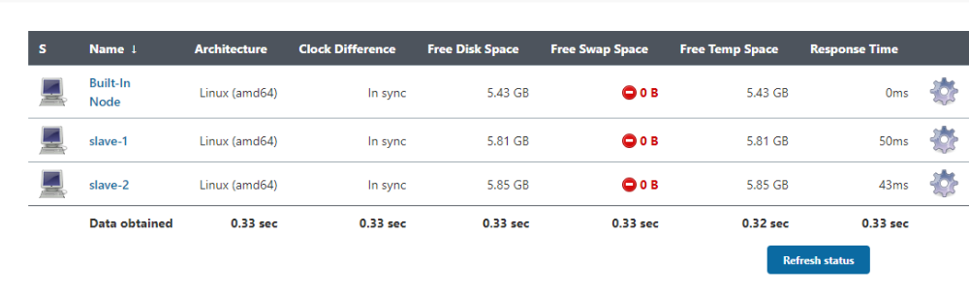
Adding Git-jobs to Jenkins slave
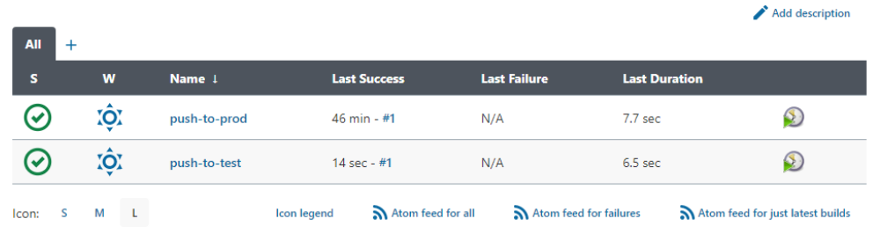

Successful build for Git-job
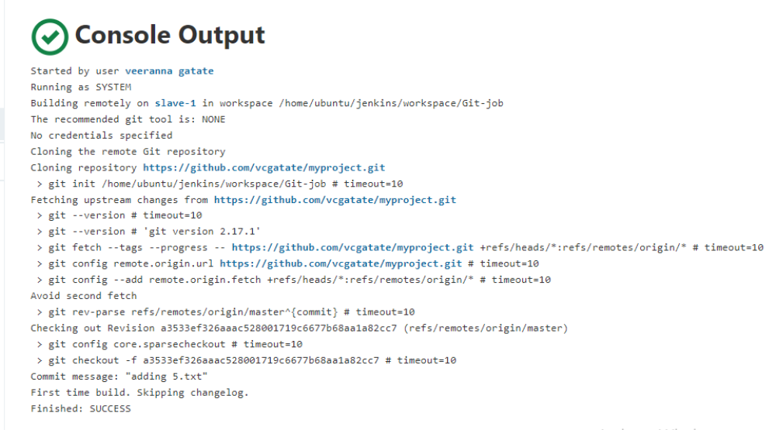
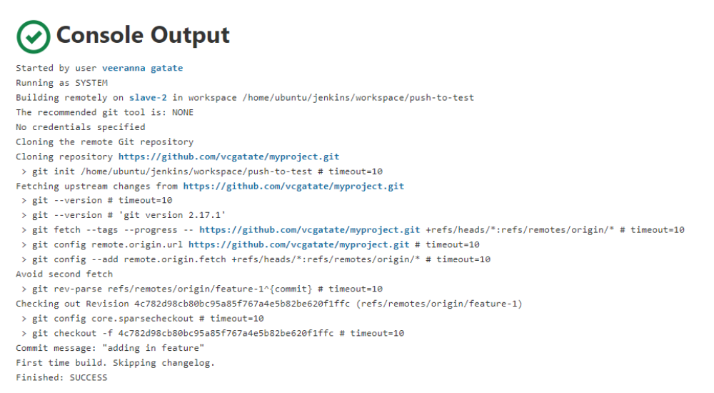
ubuntu@ip-172-31-30-81:~$ cd jenkins/
ubuntu@ip-172-31-30-81:~/jenkins$ ls
remoting workspace
ubuntu@ip-172-31-30-81:~/jenkins$ cd workspace/
ubuntu@ip-172-31-30-81:~/jenkins/workspace$ ls
Git-job
ubuntu@ip-172-31-30-81:~/jenkins/workspace$ cd Git-job/
ubuntu@ip-172-31-30-81:~/jenkins/workspace/Git-job$ ls
3.txt 4.txt 5.txt config.json main.java
ubuntu@ip-172-31-30-81:~/jenkins/workspace/Git-job$
ubuntu@ip-172-31-30-0:~$ cd jenkins/
ubuntu@ip-172-31-30-0:~/jenkins$ ls
remoting workspace
ubuntu@ip-172-31-30-0:~/jenkins$ cd workspace/
ubuntu@ip-172-31-30-0:~/jenkins/workspace$ ls
push-to-test
ubuntu@ip-172-31-30-0:~/jenkins/workspace$ cd push-to-test/
ubuntu@ip-172-31-30-0:~/jenkins/workspace/push-to-test$ ls
3.txt 4.txt 5.txt 6.txt config.json main.java
ubuntu@ip-172-31-30-0:~/jenkins/workspace/push-to-test$
On slave-1
ubuntu@ip-172-31-30-81:~$ git clone https://github.com/vcgatate/myproject.git
Cloning into 'myproject'...
remote: Enumerating objects: 16, done.
remote: Counting objects: 100% (16/16), done.
remote: Compressing objects: 100% (9/9), done.
remote: Total 16 (delta 3), reused 14 (delta 1), pack-reused 0
Unpacking objects: 100% (16/16), done.
ubuntu@ip-172-31-30-81:~$ ls
agent.jar jenkins jenkins-agent.jnlp myproject
ubuntu@ip-172-31-30-81:~$ cd myproject/
ubuntu@ip-172-31-30-81:~/myproject$ ls
3.txt 4.txt 5.txt config.json main.java
ubuntu@ip-172-31-30-81:~/myproject$ sudo nano main.java
ubuntu@ip-172-31-30-81:~/myproject$ git init
Reinitialized existing Git repository in /home/ubuntu/myproject/.git/
ubuntu@ip-172-31-30-81:~/myproject$ git add .
ubuntu@ip-172-31-30-81:~/myproject$ git commit -m "first git commit"
[master dd879c3] first git commit
Committer: Ubuntu <ubuntu@ip-172-31-30-81.us-east-2.compute.internal>
Your name and email address were configured automatically based
on your username and hostname. Please check that they are accurate.
You can suppress this message by setting them explicitly. Run the
following command and follow the instructions in your editor to edit
your configuration file:

git config --global --edit

After doing this, you may fix the identity used for this commit with:

git commit --amend --reset-author

1 file changed, 2 insertions(+)
ubuntu@ip-172-31-30-81:~/myproject$ git push origin master
Username for 'https://github.com': vcgatate@gmail.com
Password for 'https://vcgatate@gmail.com@github.com':
Counting objects: 3, done.
Compressing objects: 100% (3/3), done.
Writing objects: 100% (3/3), 317 bytes | 317.00 KiB/s, done.
Total 3 (delta 1), reused 0 (delta 0)
remote: Resolving deltas: 100% (1/1), completed with 1 local object.
To https://github.com/vcgatate/myproject.git
a3533ef..dd879c3 master -> master
ubuntu@ip-172-31-30-81:~$ cd myproject/
ubuntu@ip-172-31-30-81:~/myproject$ ls
3.txt 4.txt 5.txt config.json main.java

ubuntu@ip-172-31-30-81:~/myproject$ cat main.java
this is a sample Java

This is after first commit
ubuntu@ip-172-31-30-81:~/myproject$ sudo nano main.java
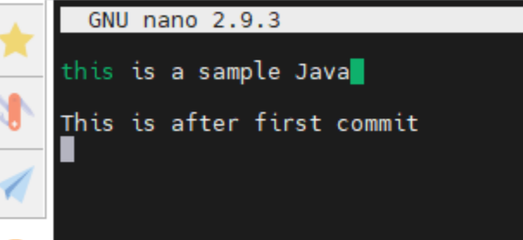
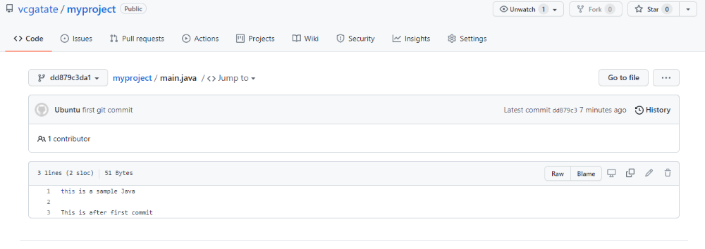

On slave-2
ubuntu@ip-172-31-30-0:~$ git clone https://github.com/vcgatate/myproject.git
Cloning into 'myproject'...
remote: Enumerating objects: 19, done.
remote: Counting objects: 100% (19/19), done.
remote: Compressing objects: 100% (11/11), done.
remote: Total 19 (delta 4), reused 17 (delta 2), pack-reused 0
Unpacking objects: 100% (19/19), done.
ubuntu@ip-172-31-30-0:~$ ls
agent.jar jenkins jenkins-agent.jnlp myproject
ubuntu@ip-172-31-30-0:~$ cd myproject/
ubuntu@ip-172-31-30-0:~/myproject$ ls
3.txt 4.txt 5.txt config.json main.java
ubuntu@ip-172-31-30-0:~/myproject$ sudo nano main.java
ubuntu@ip-172-31-30-0:~/myproject$ git init
Reinitialized existing Git repository in /home/ubuntu/myproject/.git/
ubuntu@ip-172-31-30-0:~/myproject$ git add .
ubuntu@ip-172-31-30-0:~/myproject$ git commit -m "this is from feature-1"
[master f4f0a2e] this is from feature-1
Committer: Ubuntu <ubuntu@ip-172-31-30-0.us-east-2.compute.internal>
Your name and email address were configured automatically based
on your username and hostname. Please check that they are accurate.
You can suppress this message by setting them explicitly. Run the
following command and follow the instructions in your editor to edit
your configuration file:

git config --global --edit

After doing this, you may fix the identity used for this commit with:

git commit --amend --reset-author

1 file changed, 2 insertions(+)
ubuntu@ip-172-31-30-0:~/myproject$ git push origin master
Username for 'https://github.com': vcgatate@gmail.com
Password for 'https://vcgatate@gmail.com@github.com':
Counting objects: 3, done.
Compressing objects: 100% (3/3), done.
Writing objects: 100% (3/3), 336 bytes | 336.00 KiB/s, done.
Total 3 (delta 1), reused 0 (delta 0)
remote: Resolving deltas: 100% (1/1), completed with 1 local object.
To https://github.com/vcgatate/myproject.git
dd879c3..f4f0a2e master -> master
ubuntu@ip-172-31-30-0:~/myproject$ git push origin feature-1
error: src refspec feature-1 does not match any.
error: failed to push some refs to 'https://github.com/vcgatate/myproject.git'
ubuntu@ip-172-31-30-0:~/myproject$ git push origin --all
Username for 'https://github.com': vcgatate@gmail.com
Password for 'https://vcgatate@gmail.com@github.com':
Everything up-to-date
